Sunday | Monday | Tuesday | Wednesday | Thursday | Friday | Saturday
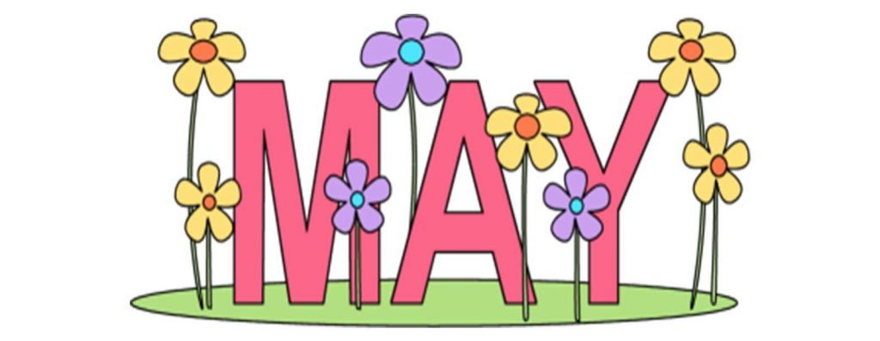 |  |  |  |  | 1 Lunch 11-2pm  Happy Hour  4-6  Dinner Service  6-9pm  Ladies Chair Yoga 9:15 Ladies Yoga 10:00 | 2  Lunch 11-2pm  Happy Hour  4-6  Dinner Service  6-9pm
3  Lunch  11-2 pm | 4  Course, Range  and  Clubhouse  Closed  Ladies Chair Yoga 9:15  Ladies Yoga 10:00 | 5  Lunch  11-2pm    OLGA Meeting and Lunch | 6  Lunch 11-2pm  Happy Hour 4-6  Dinner Service 6-9pm    EVENT | 7  Lunch  11-2pm  MGA Meeting and Dinner | 8 Lunch 11-2pm  Happy Hour 4-6  Dinner Service 6-9pm    Clinch Lions Club  Scramble  Course Closed  Ladies Chair Yoga 9:15 Ladies Yoga 10:00 | 9  Lunch 11-2pm  Happy Hour  4-6  Dinner Service  6-9pm
  10  Lunch 11-2 pm Reservations only | 11  Course, Range  and  Clubhouse  Closed  Ladies Chair Yoga 9:15  Ladies Yoga 10:00 | 12  Lunch  11-2pm | 13  Lunch 11-2pm  Happy Hour  4-6  Dinner Service  6-9pm |   14 Lunch 11-2pm    Colonial Dames Luncheon | 15  Lunch 11-2pm  Happy Hour  4-6  Dinner Service  6-9pm  Ladies Chair Yoga 9:15 Ladies Yoga 10:00 | 16  Lunch 11-2pm  Happy Hour  4-6pm  Dinner Service  6-9pm  Bokor Wedding
17 Lunch 11-2 pm    2A State Championship  PCHS Boys & Girls  Course Closed | 18  2A State Championship  PCHS Boys & Girls  Course Closed  Ladies Chair Yoga 9:15 Ladies Yoga 10:00 | 19 Lunch 11-2pm  2A State Championship  PCHS Boys & Girls  Course Closed | 20  Lunch 11-2pm  Happy Hour  4-6  Dinner Service  6-9pm | 21    Lunch 11-2pm | 22  Lunch 11-2pm  Happy Hour  4-6  Dinner Service  6-9pm  Ladies Chair Yoga 9:15 Ladies Yoga 10:00 | 23  Lunch 11-2pm  Happy Hour  4-6  Dinner Service  6-9pm
24 Lunch  11- 2 pm |   25  Pool Opening  Course, Range, and  Clubhouse OPEN   | 26  Lunch  11-2pm | 27  Lunch 11-2pm  Happy Hour  4-6  Dinner Service  6-9pm | 28  Lunch 11-2pm | 29  Lunch 11-2pm  Happy Hour  4-6  Dinner Service  6-9pm  Ladies Chair Yoga 9:15 Ladies Yoga 10:00 | 30  Lunch 11-2pm  Happy Hour  4-6  Dinner Service  6-9pm  Rudd Wedding
31
Lunch
11-2 pm

